

Intelligent Enterprise Systems
Year 2 (2025/26), Semester 3

SCHOOL OF INFOCOMM TECHNOLOGY
Diploma in Data Science

ASSIGNMENT 2

Tutorial Group | : | T03
Student Name | : | Tiffany Loy Zhen Min
Student Number | : | S10266970K

Table of Contents
SCHOOL OF INFOCOMM TECHNOLOGY 1
1. E-Learning Completion 3
2. Creating Stories using SAP Analytics Cloud 4
a) Pertaining to Sales and Market Trends 5
b) Pertaining to Product and Customer Insights 11
c) Pertaining to Cost and Profitability 16
3. Dashboard 24
a) Sales and Market Trends 24
b) Product and Customer Insights 26
c) Cost and Profitability 28
4. Smart Discovery 30
5. Reflection 33

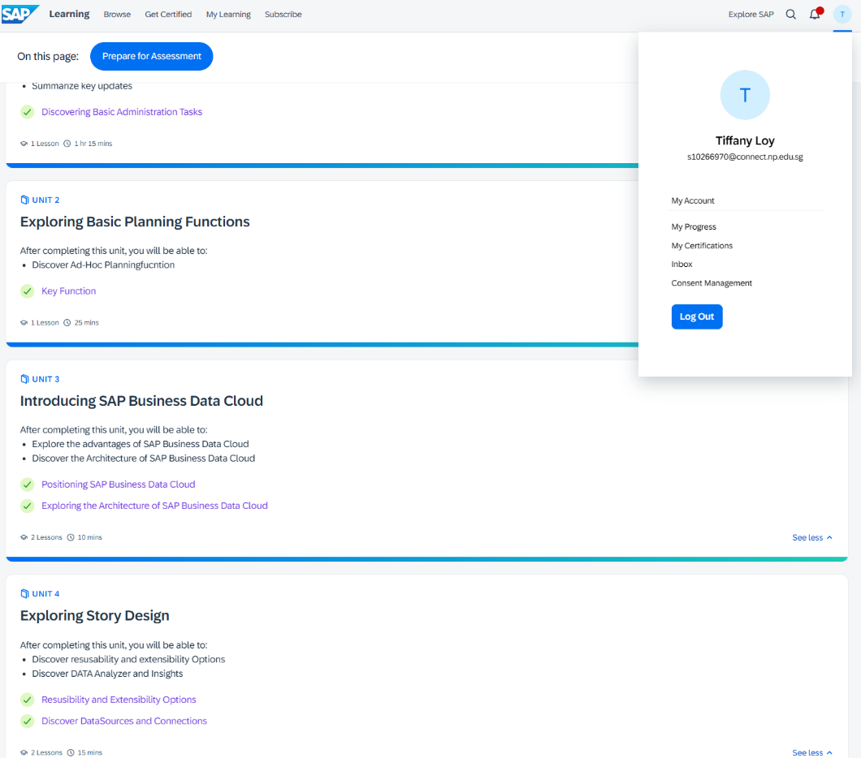
E-Learning Completion
Problem with SAP Learning where it says 3/4 completed but here shows all already completed.
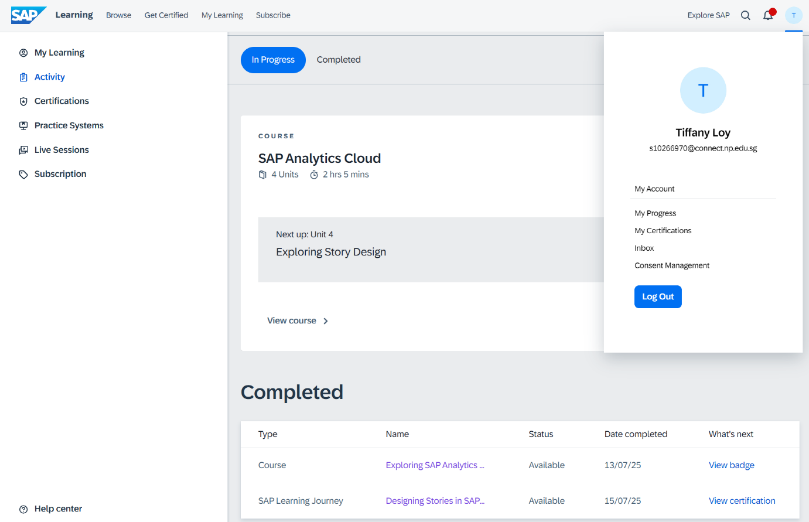

Creating Stories using SAP Analytics Cloud
Data Preparation
The data contained 20281 rows and 29 columns, it contains information regarding customers, times, geographical, product details and sales. Most of the fields in the data are generally well-populated with no missing values.

Some calculated fields are created to conduct deeper analysis in the data. These are the calculated fields I have created:

- No of Days to Deliver: Difference between the shipping date and order date.
- Shipping Date – Order Date
- During exploration, there were negative values. These could be from data entry errors. Hence these negative values are being filtered out from the dataset.

- Cost of Goods (COGS): Total cost that the company spends on the order
- Includes Shipping Costs, Storage Costs, Personnel Costs, Purchasing Costs, Selling Costs

- Profit Margin %: The ratio between COGS and Sales in percentage.

- Personnel Costs/Purchasing Costs/Selling Costs/Shipping Costs/Storage Costs (Neg)
- Since these costs all results in a lost for the company, I made new calculated fields where they are negative for a waterfall chart.

- Average Discount: Average Discount for each order
- I assumed that the discount is the value applied to the entire order and not each individual items
- I divided the sum of the total discounts by the number of orders which is 20281

Pertaining to Sales and Market Trends
- Line graph that shows the total sales over time across the months from 2019 – 2021.
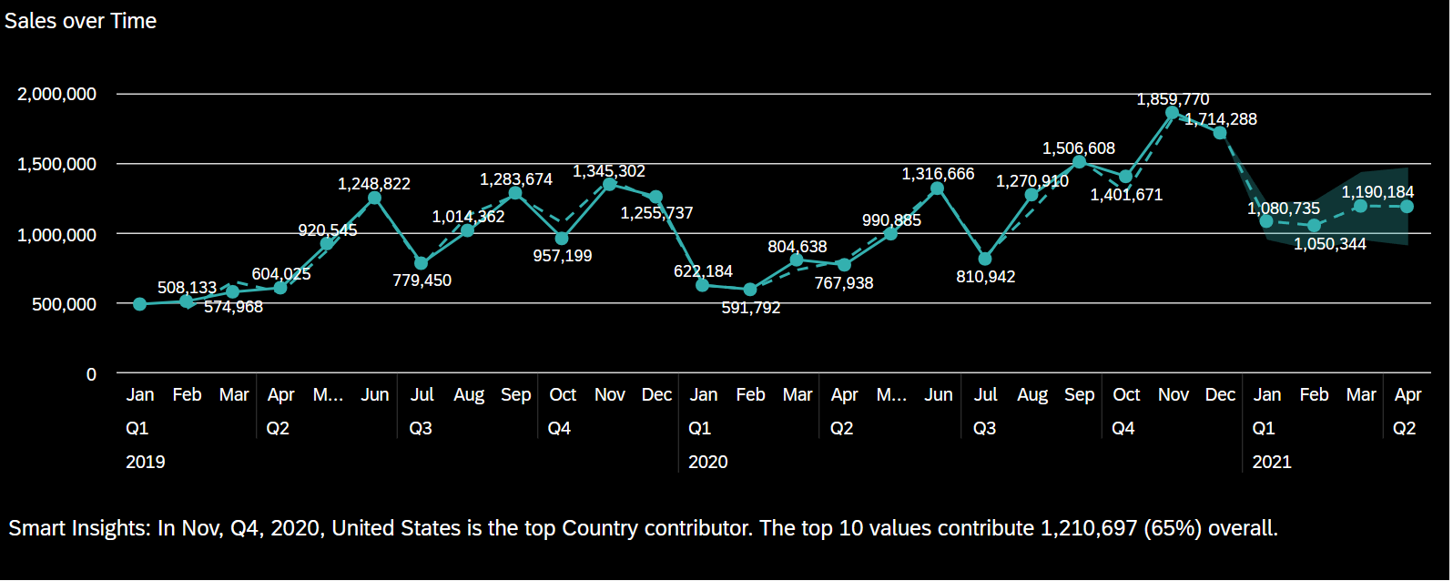

The line chart effectively shows the monthly sales performance from January 2019 to April 2021. Making it easy to see seasonal trends, fluctuations and peak periods. Each point on the graph includes the exact sales value, allowing one to clearly observe the changes each month and overall progress.
From the graph it shows that there is typically a steady increase from Q1 till the end of Q2 in June. However, there is visible dips during Q3 periods. Additionally, it typically peaks at the end of year where in November 2020, there was the highest recorded sales of 1,859,77. But in Q1 it drops back down.
The graph also includes a forecast line which is dotted and the forecast section (light shaded area), showing projected values beyond January 2021, which provides insight into expected future sales performance.

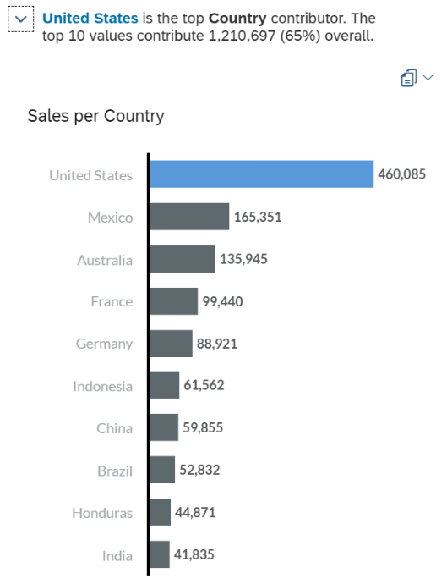
Smart Insights:
According to Smart Insights, the United States was the top contributing country during the peak month (November 2020), and the top 10 contributors collectively accounted for 1,210,697 (65%) of total sales during that period.
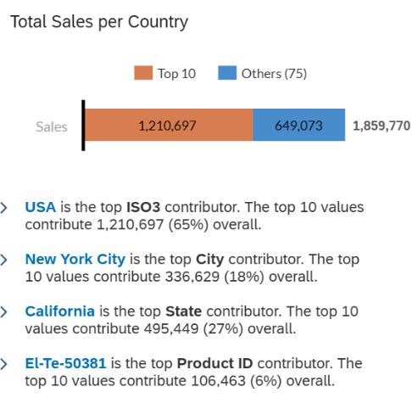

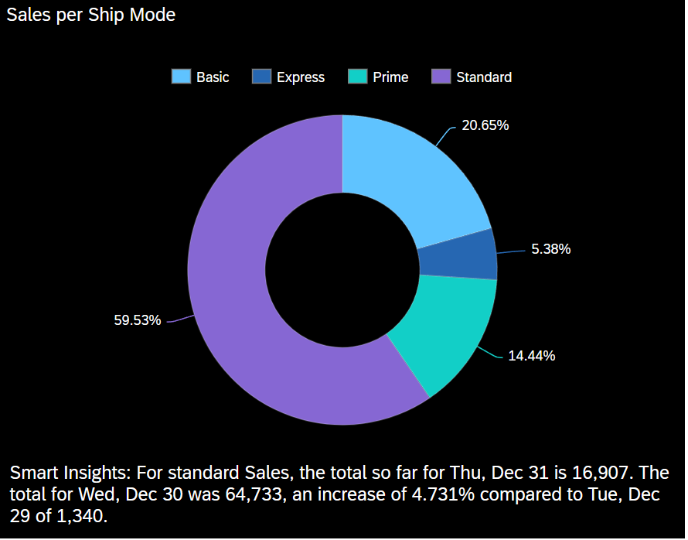
- Donut chart that shows the shipment mode used for all the sales.

The donut chart visualizes the distribution of sales across different shipping modes, allowing for a clear comparison of customer preferences. The chart uses distinct colours to represent each mode—Standard, Basic, Prime, and Express—which enhances readability and segmentation.

It can be seen that standard shipping dominates with 59.53% of total sales, indicating it is the most widely used and preferred option among customers. Basic shipping follows with 20.65%, suggesting a strong preference among cost-conscious customers. Prime accounts for 14.44%, likely appealing to those willing to pay more for speed or perks. Express shipping has the lowest share at 5.38%, possibly due to its higher cost or limited necessity.

It can be inferred that overall, customers would prefer prioritizing costs over getting their products quickly. This also indicated brand reputation as most customers trust that Standard and Basic shipping methods are sufficient to receive their products. Information on the different shipping modes can allow for better resource allocation, optimizing the top shipping modes.

Smart Insights:
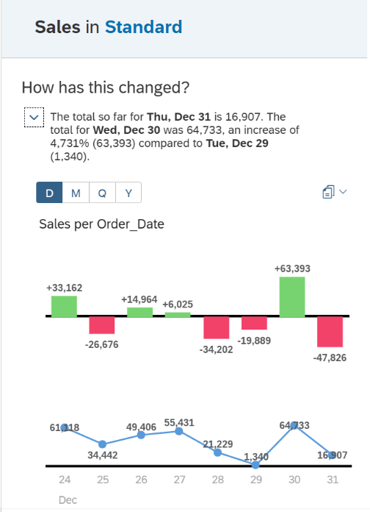
Smart Insights on the visual gave me more information on the most popular shipping mode which is Standard. It shows the sales over time for the shipping method by each order date.

On Dec 31, sales reached 16,907 units. On Dec 30, there were 64,733 sales, a 4.731% increase over Dec 29’s 1,340 sales.

These insights suggest that Standard shipping not only holds the largest market share but also shows dynamic day-to-day fluctuations—likely influenced by seasonal demand, promotions, or logistical factors. This could be useful for logistics planning, inventory distribution, and targeted marketing based on preferred shipping modes.

- Bar graph that shows the sales per market
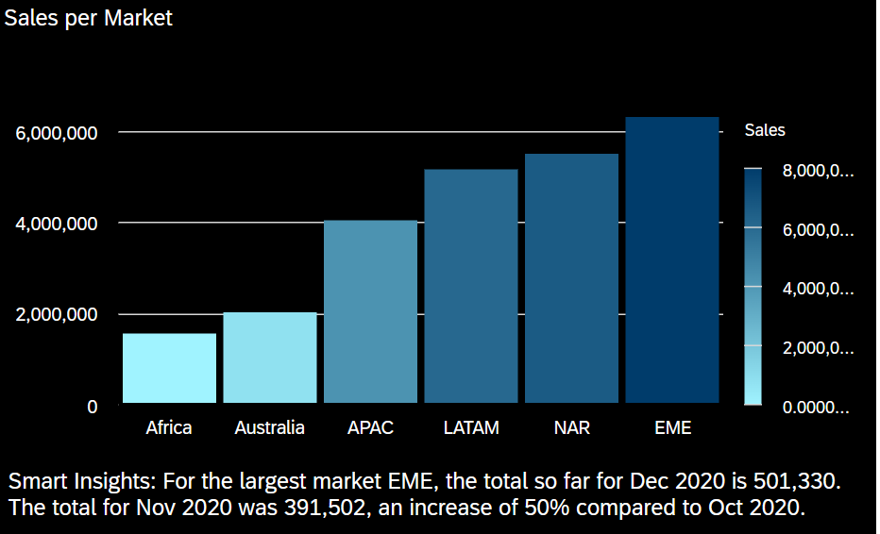
The vertical bar chart shows a breakdown of total sales by market region, with each bar representing a distinct market – Africa, Australia, APAC, LATAM, NAR and EME. The shading gradient visually shows the scale of sales, with darker colours indicating higher sales.
It can be seen that the EME (Europe, Middle East) market dominates with the highest total sales, exceeding 6 million. NAR (North America) and LATAM (Latin America) are strong performers as well, both around the 5 million range. Africa and Australia has the lowest sales, indicating smaller market size or lower product penetration.
To increase profitability, the company can continue capitalizing in the higher performing markets, increase marketing at smaller markets and expand to more regions.

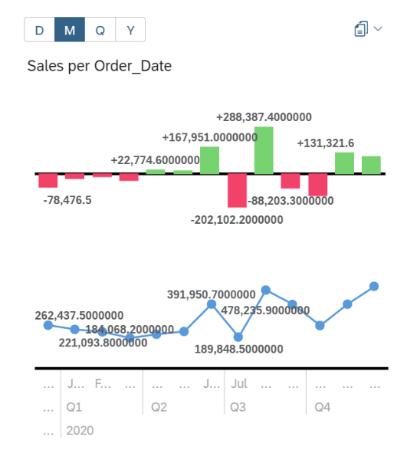
Smart Insights:

Smart insights on the bar graph gave me more information on the top contributor, EME. In December 2020, they had 501,330 in sales. In November it had 391,502 indicating a 50% increase compared to October 2020. The monthly increase in EME in Q4 links back to the first line chart where the sales tend to peak in Q4 before decreasing at each start of the year.

- Geo Map that shows the sales across the cities in the world.
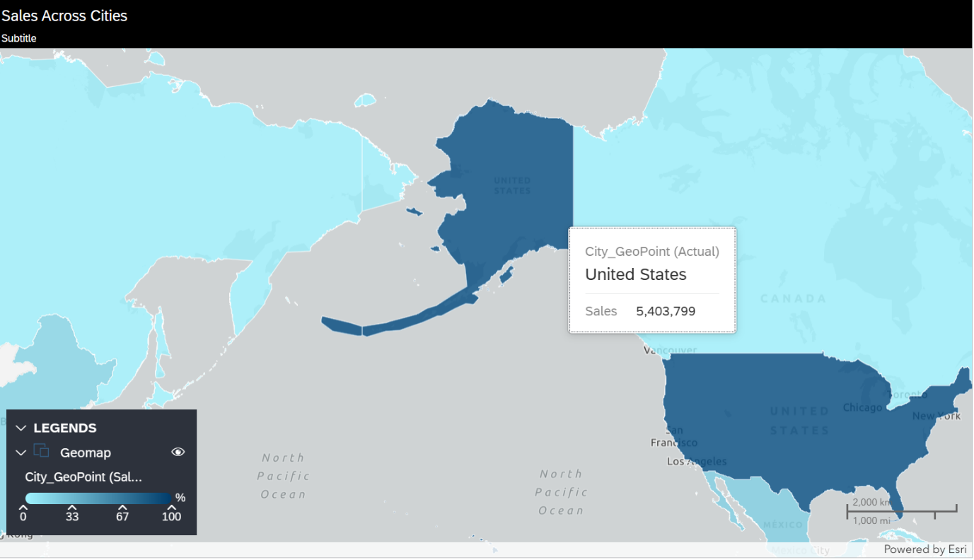
The geo map has a spatial representation of sales distribution by geographic location, showing how sales vary across countries and cities. The intensity of the blue shading reflects the percentage contribution of each location, making it easy to see high-performing areas.

The United States stands out prominently with 5,403,799 in total sales, shown in dark blue indicating a high contribution closer to 100% on the legend scale. Countries with lighter blue tones like Canada and parts of Asia represent lower sales contributions, suggesting smaller markets.

The information provided can also be found in the smart insights of chart ai but it is better in a geo map format. Showing the sales in each city in this form gives us a bird’s eye view on the performance of the sales, it can be seen more clearly.

The company can use the map to identify regional performance gaps, targeting marketing or logistics efforts and possibly tap into new markets.

Pertaining to Product and Customer Insights
- Tree map that shows the sales based on the different sub-categories.
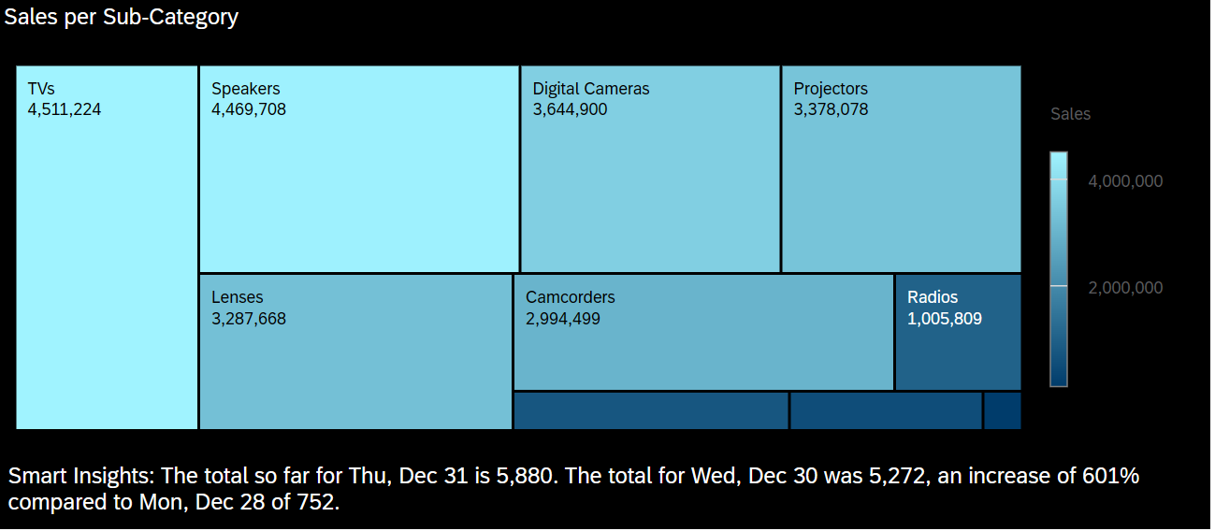
The treemap shows the sales distribution across product sub-categories, making it easy to identify the better performing and underperforming products. The size and shade of each block represent the volume of sales, with larger and lighter blue blocks indicating higher sales.

It can be seen that TVs and Speakers are the two leading sub-categories, contributing 4.51M and 4.47M in sales respectively with Digital Cameras and Projectors follow closely, each exceeding 3.3M in sales, indicating consistent demand in visual/audio tech.

This highlights that certain sub-categories especially those related to home entertainment like TVs and Speakers dominate the market. Hence businesses can use this information to optimize inventory management and have promotions for lower-performing items.

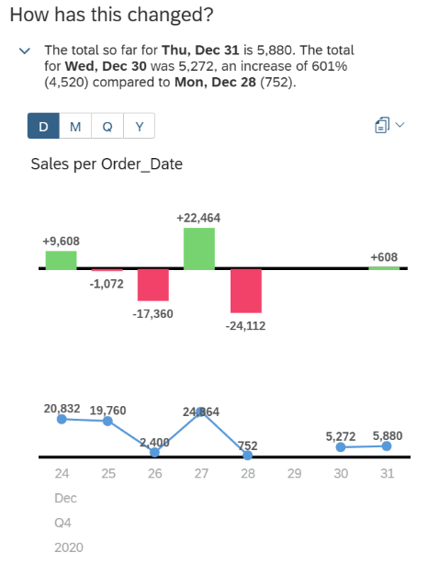
Smart Insights:
Smart insights on the tree map gave me more information on TVs sales. On Dec 31, sales reached 5,880. On Dec 30 it recorded 5,272, which is a 601% increase from Dec 28, where sales were only 752. Overall, it can be seen that the sales during this period is still relatively high compared to other quarters of the year.

- Table that shows the products with the top sales as well as the quantity sold, and profit earned.
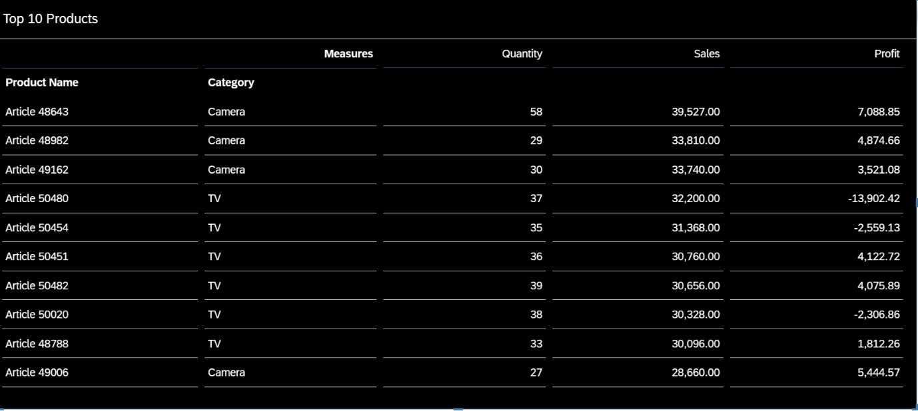
The table highlights the top 10 products based on sales, alongside their associated categories, quantities sold, and profit values. It shows clearly the items that are bringing in the revenue and how profitable they are.

The highest-selling product is Article 48643 (Camera) with 58 units sold and $39,527 in sales, generating a strong profit of $7,088.85. Cameras dominate the upper half of the table, indicating consistent performance in that category.

Products like Article 50480 and Article 50454 (TVs) show high sales volume but return negative profit, suggesting either high costs, low margins, or possible discounting issues. This suggests that they should change their pricing and use the products popularity to earn profit. On the other hand, Article 50451 and Article 50482 (also TVs) report healthy profits, indicating inconsistency in profitability across the same product category.

This analysis suggests that while both Cameras and TVs are strong in terms of sales, only certain items within those categories are efficiently profitable. Hence, businesses should consider pricing adjustments and also reinforce supply and marketing of top products.

- Scatter plot that shows the discounts by the sales quantity of each category.
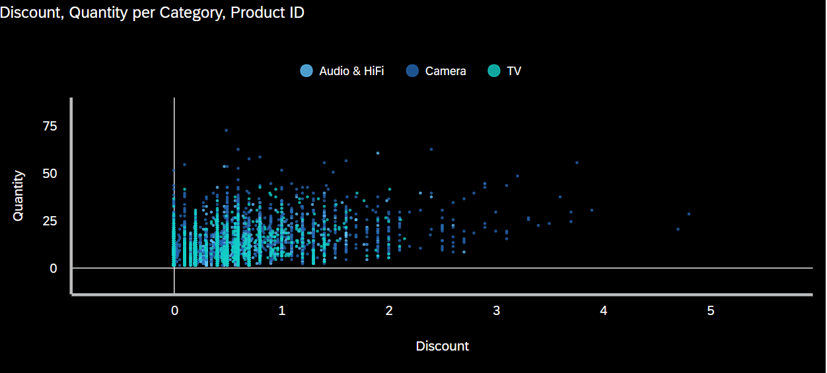
This scatter plot shows the relationship between discount levels and quantity sold segmented by product category. Each dot represents a product instance, coloured according to its category.

In the graph it shows that the majority of sales are clustered around low discount values regardless of product category. This suggests that most sales are made with minimal or no discounting. However there are still higher discounts of values above 2 that are less frequent, especially within the Camera category, indicating occasional deep-discount promotions.

There is no strong linear correlation between discount and quantity indicating that products sold at higher discounts do not consistently yield higher quantities, especially for TVs and Audio products. Since these categories appear more in the lower discount range, it also indicates that they are less reliant on discounts to increase sales.

However, it can also be seen that quite a few items in the lower discount range have very few sales, suggesting that they should consider adding discounts to these items. Additionally, they could decrease those with very extreme discounts to increase their profits.

- Line graph that shows the profit earned from the different categories across the quarters from 2019 – 2021.
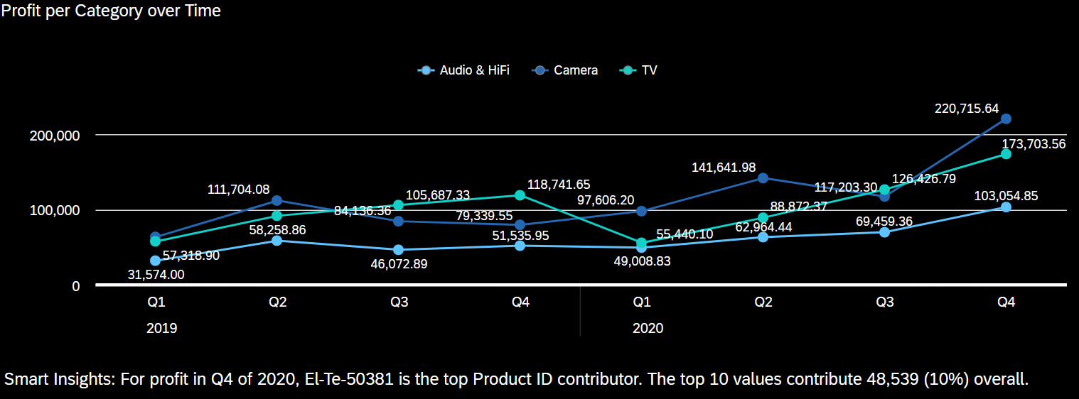
This line chart shows the quarterly profit trends from 2019 to 2020, categorized by product lines. Each line traces the profit trajectory for its respective category, helping to reveal growth patterns, seasonal fluctuations, and category-level performance shifts.

Overall, Camera saw a strong growth trend, with profits rising sharply from 117,203 in Q3 2020 to a peak of 220,715 in Q4 2020, making it the top-performing category by the end of the period. TV maintained relatively high profits throughout. However right after peaking at 118,741 in Q4 2019, there was a steep drop to 55,440 in Q1 2020 before climbing back to 173,703 by Q4 2020. Audio & HiFi was relatively constant with small decreases but overall an increase in profit.

The strong Q4 performances may possibly be due to seasonal spikes, hence they should increase marketing and possible campaigns to get more customers. Additionally, the sudden rise for Camera indicates that it is a category to continue watching for expansion.

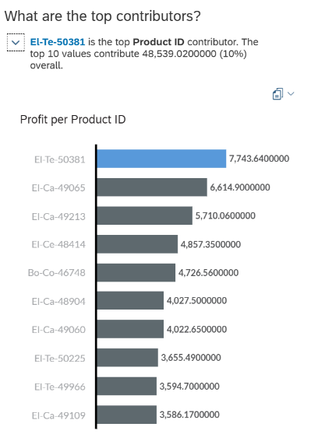
Smart Insights:
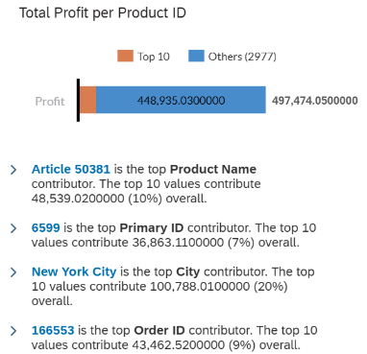
In Q4 2020, the top product contributor to profit was El-Te-50381, significantly impacting the surge seen in the Audio & HiFi category. The top 10 product IDs accounted for 48,539 in profit, contributing 10% of the total, suggesting profit is concentrated in a small set of high-performing products.
- Stacked area that shows the number of days it takes to deliver each product category based on the region the customer stays in.
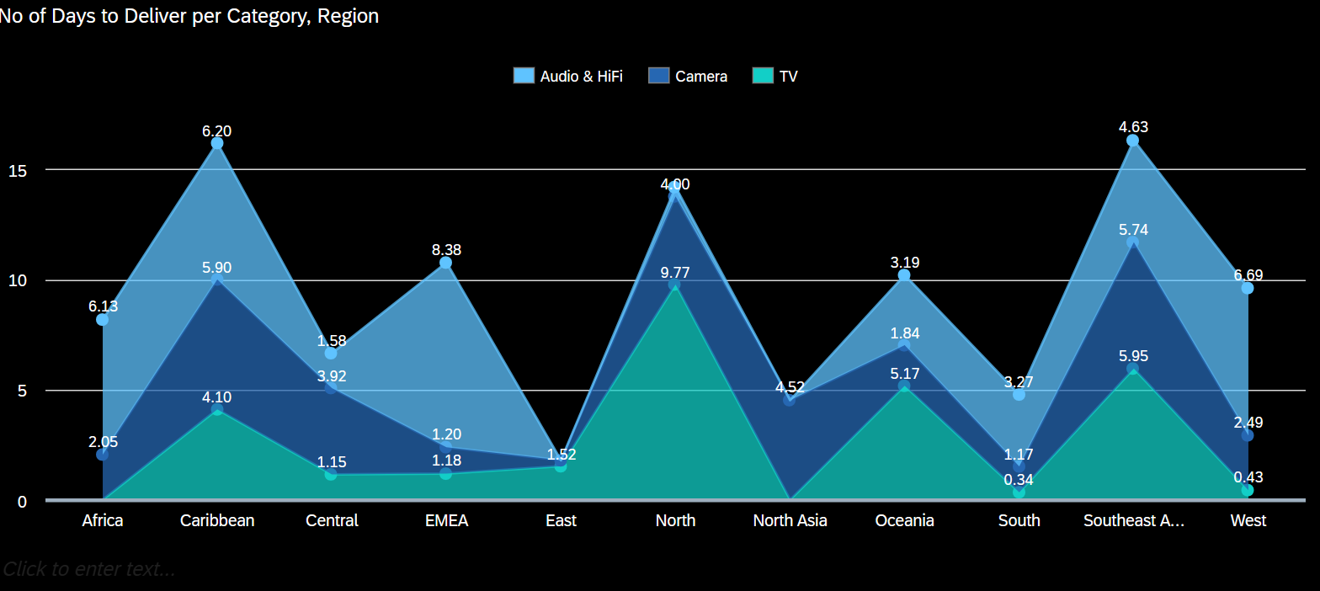
This area chart shows the average number of delivery days across various global regions, broken down by product categories. The visualization highlights how delivery times vary not only by geography but also by product type. Additionally, there were negative values that I have since filtered out.

It can be seen that the North and Caribbean regions report the longest delivery times, with peaks of 9.77 and 6.20 days respectively that are primarily driven by the TV and Audio & HiFi categories. West, and South show significantly shorter delivery times, particularly for TVs, suggesting more efficient distribution or localized supply chains.

In regions like Central, East, and South, delivery durations are relatively moderate but still vary across categories, implying that no single region is universally efficient for all product types, hence they would not need targeted marketing on all product types at the different regions.

Instead, they should have better logistics management and regional warehousing strategies to shorten delivery for those extreme values. This emphasizes the need for tailored logistics approach instead marketing for all.

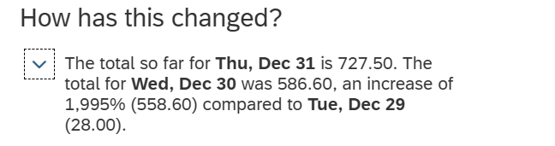
The smart insights for this graph provided was very wrong as they added the total delivery dates. Hence I did not add it to the graph.

Pertaining to Cost and Profitability
- Heatmap that shows the profit margin for the different categories based on their order date.
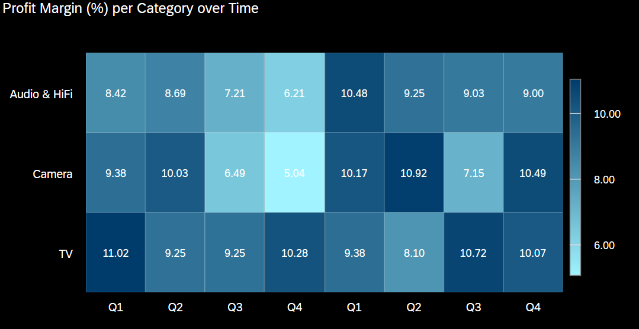
The heatmap represents the quarterly profit margin percentages for three product categories, allowing quick comparison of performance over time through both numeric values and colour gradients, where a darker shade indicates a higher profit margin.

TVs consistently demonstrate the highest profit margins, particularly in Q1 of 2019 at 11.02% and Q3 of 2020 at 10.72%, this indicates strong pricing control or lower cost structures. Cameras show volatile margins, dropping to 5.04% in Q4 2019, then rebounding to 10.92% in Q2 2020. This suggests sensitivity to either promotional pricing or operational inefficiencies. Audio & HiFi maintains more stable margins, ranging between 6.21% and 10.48%, with a noticeable low of 6.21% in Q4 2019, followed by a peak of 10.48% in Q1 2020. Q4 2019 stands out across the board for being a relatively low-margin period, possibly due to aggressive discounting during year-end promotions.

Overall, it can be seen that TVs are the most consistently profitable category, suggesting a potential focus area for sustaining high-margin strategies. The Camera category requires deeper review, especially around Q4 promotional periods, to identify cost or pricing leakages.

- Pie chart that shows the percentage of sales from the different segments.
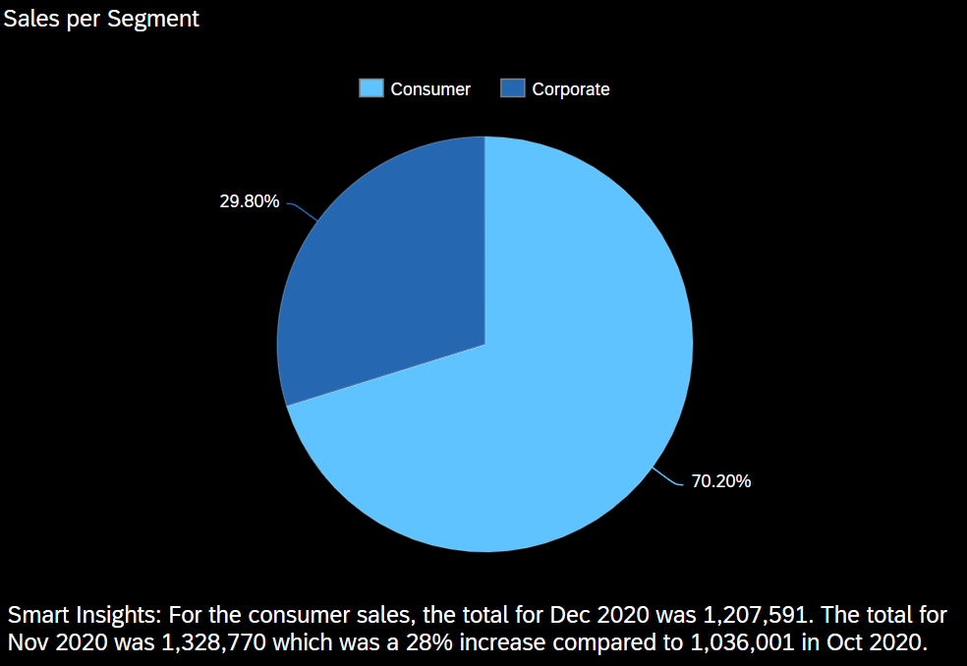

The pie chart shows a breakdown of total sales by customer segment, giving a clear snapshot of who the primary customers are.

The consumer segment accounts for the majority of sales, making up 70.20% of the total. The corporate segment contributes the remaining 29.80%, suggesting a smaller but still significant portion of revenue.

The large amount of consumer sales shows that it’s the main market driver. They could have promotional campaigns or loyalty programs to prioritize this customer market.

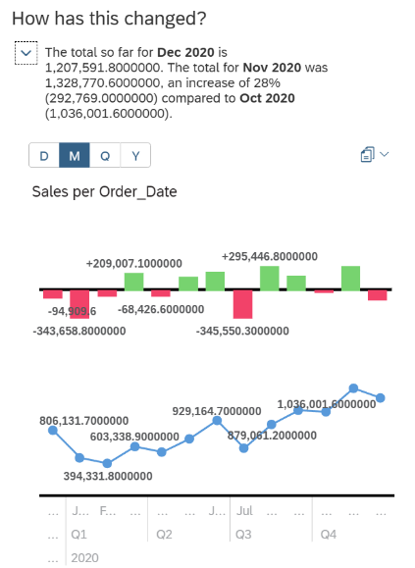
Smart Insights:
For the Consumer segment, sales totalled 1,207,591 in Dec 2020. This follows a strong performance in Nov 2020 with 1,328,770, representing a 28% increase from Oct 2020 of 1,036,001.

This sharp monthly rise implies strong performance in Q4, likely due to holiday shopping or targeted end-of-year campaigns.

- Waterfall chart that shows the starting sales slowly deducting the different costs leading to the overall profit.
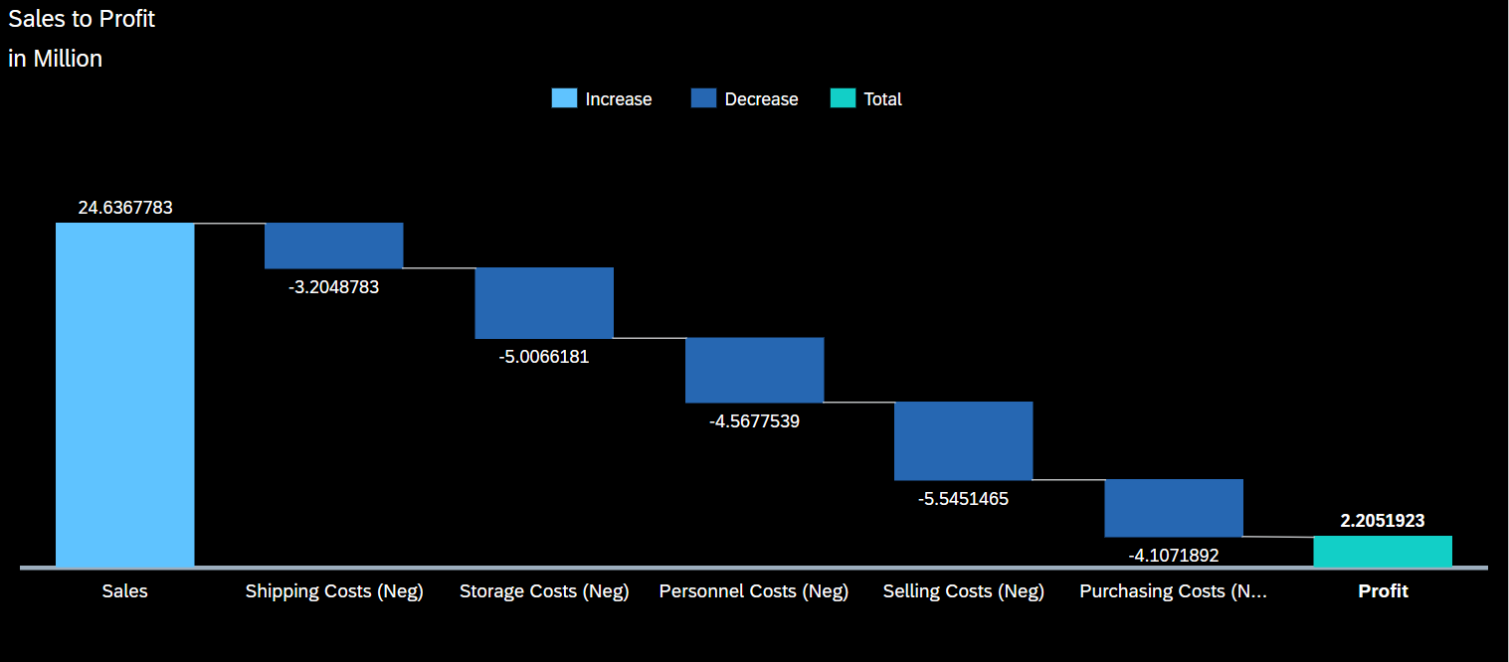

This waterfall chart shows how Sales revenue is reduced by various cost components to arrive at the final Profit. It offers a clear and intuitive view of how each cost category contributes to or detracts from profitability.

The chart begins with Sales of 24.64 million, which is the total revenue before expenses. Sequentially, the chart subtracts – Shipping Costs (–3.20M), Storage Costs (-5.01M), Personnel Costs (-4.57M), Selling Costs (-5.55M), Purchasing Costs (-4.11M). After all deductions, the business is left with a net profit of 2.21 million, represented as the final positive bar in teal.

Selling Costs are the largest cost component, followed closely by Storage and Purchasing Costs, suggesting a potential focus area for optimization. Despite significant overhead, the company still maintains a positive profit, but its only roughly a 9% margin. This visualization helps them quickly assess which cost areas impact margins the most and where cost-saving initiatives may yield higher returns.

- Combined line and bar graph that shows the cost of goods and sales across the quarters from 2019 – 2020 along with the profit margin.
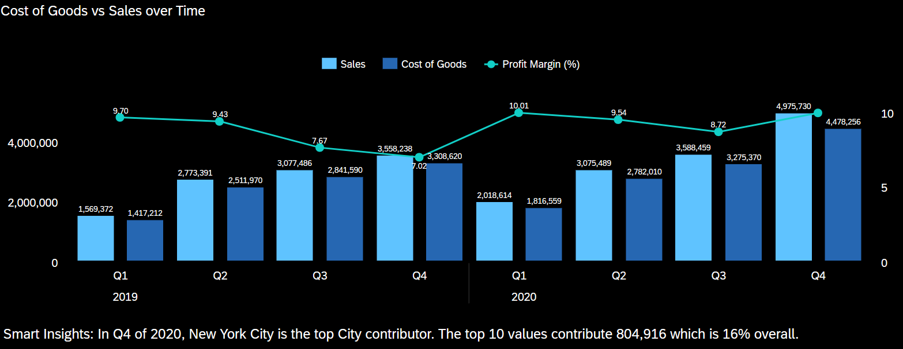

This combination chart shows the relationship between Sales, Cost of Goods, and the resulting Profit Margin (%) across quarterly periods from 2019 to 2020. It helps in understanding the profitability trend and operational efficiency over time.

The overall Sales and Cost of Goods (COGS) both generally increase over time, especially in Q4 of both years. Q4 2020 recorded the highest sales at nearly 4.98M, and the highest COGS at 4.48M, yet still maintained a healthy margin close to 10%.

On the other hand, the profit margin showed several fluctuations. From Q1 to Q4 of 2019, there was a gradual decrease in profit even though the sales were increasing. However in Q1 2020 when there was a drop in sales, the profit recovered to 10.01%.

In late 2019, the rising costs was not matched by revenue growth. Hence, higher sales does not necessarily mean a higher profit. The company should use this information to control their cost of goods. The close alignment of sales and cost of goods in Q4 2020 suggest possible scaling operations, hence having a high profit margin.

Smart Insights:
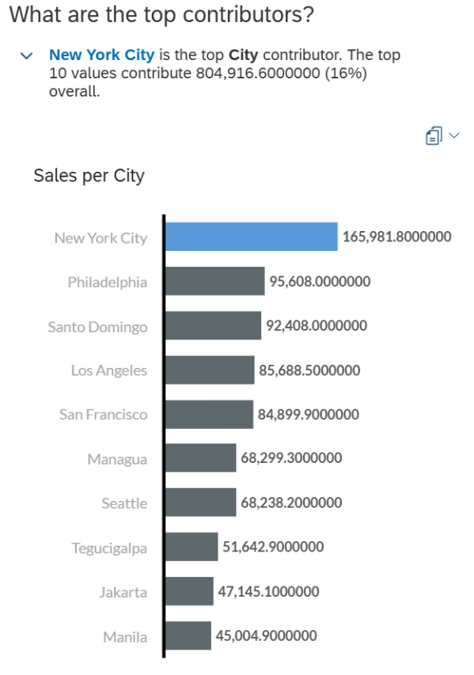
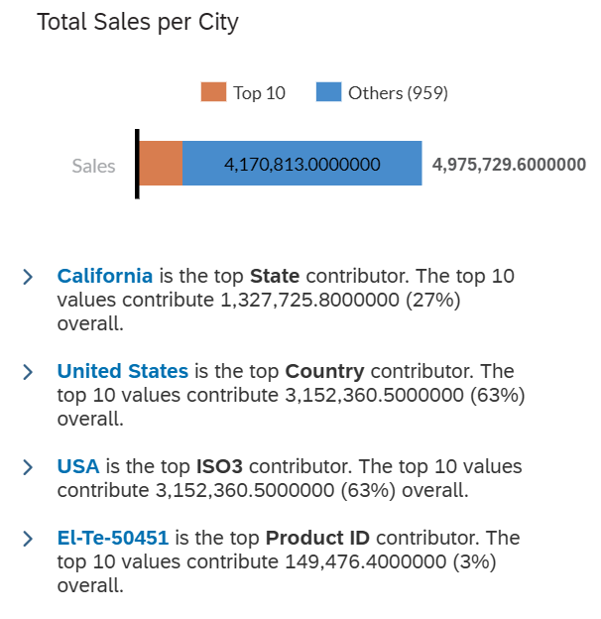
New York City as the top city contributor in Q4 2020 highlighting a geographic focus area for high-performing sales. Additionally, the top 10 cities only contribute 16% of total sales indicating that they should continue targeting global sales and not specific cities.

- Stacked bar graph that shows the individual different costs for the different sub categories.
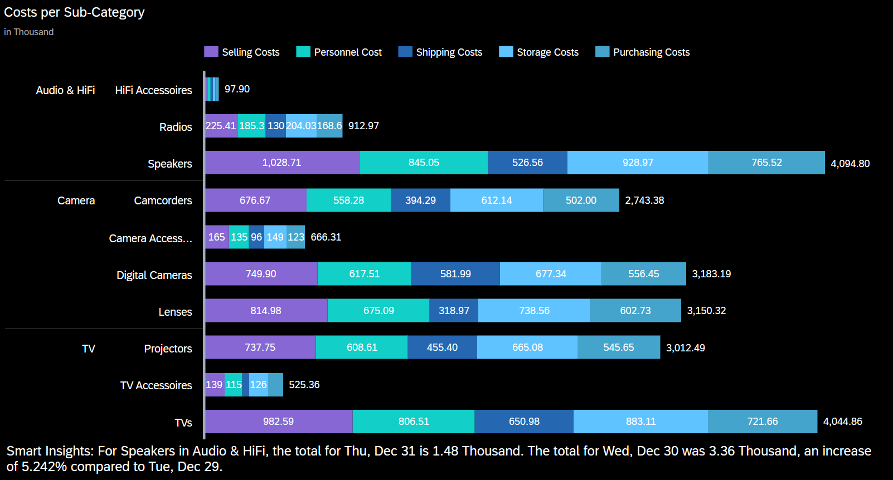

This stacked bar chart shows the total operational costs per sub-category for the five key cost components. Each sub-category falls under a broader category like Audio & HiFi, Camera, or TV.

It can be seen that Speakers in Audio & HiFi has the highest total cost at 4,094.80K, with the largest share being Selling Costs at 1,028.71K followed by Purchasing Costs 765.52K. TVs in the TV category also show similar high total costs at 4,044.86K with a significant portion from Selling at 982.59K and Purchasing at 721.66K. HiFi Accessories, Camera Accessories and TV Accessories have relatively lower total costs but still show a mix of cost contributions.

Overall, in almost every sub-category, Purchasing, Selling and Storage Costs are consistently large contributors, suggesting that inventory management and procurement are major cost drivers.

It can be observed that cost optimization opportunities exist particularly in Selling and Purchasing costs, especially for high-cost sub-categories like Speakers and TVs. The high Storage Costs across sub-categories indicate potential inefficiencies in warehousing or stock rotation strategies.

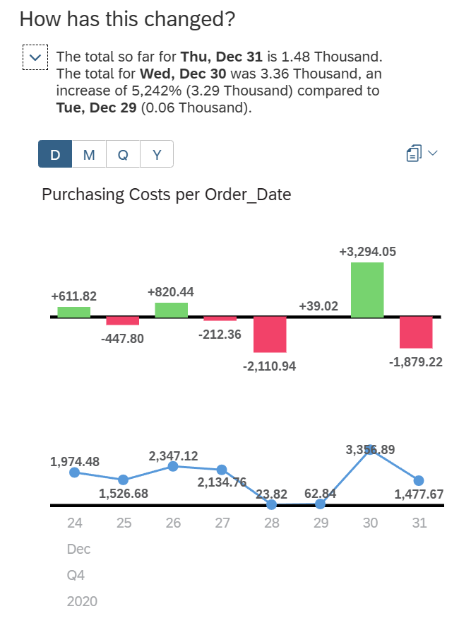
Smart Insights:

Smart Insights shows that costs for Speakers in Audio & HiFi was 1.48 Thousand on Thu, Dec 31. On Wed, Dec 30 it was 3.36 which was a 5.242% increase from Tue, Dec 29. This increase highlights potential seasonal trends worth monitoring.

Dashboard

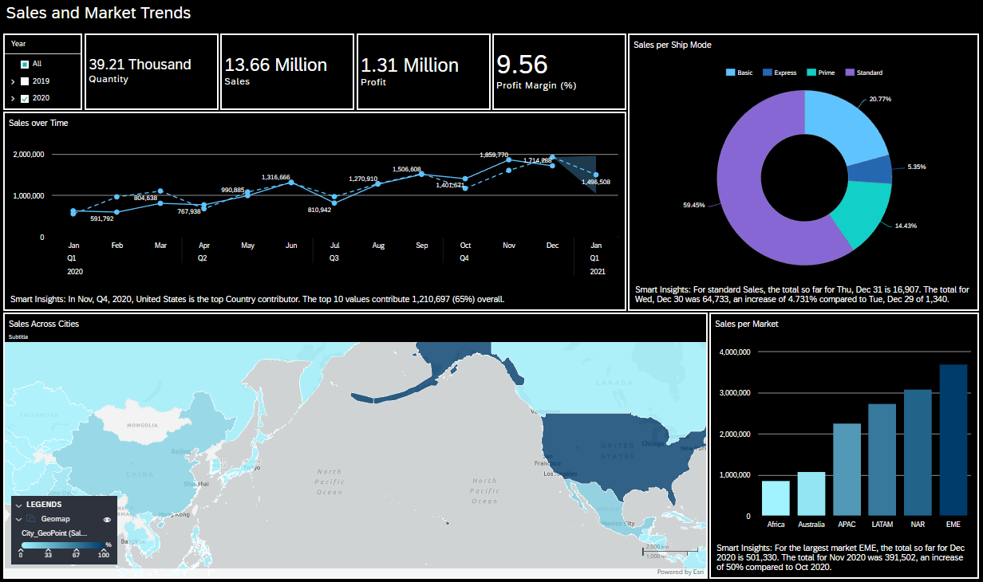
Sales and Market Trends

This dashboard provides an overview of sales performance metrics including quantity sold, revenue, profit and profit margin, while also examining sales distribution across time, ship modes, cities, and global markets. It is especially useful for identifying consumer behaviours and the current market trends.

The KPIs at the top shows the total performance for the selected year 2020. There were 39.21K units sold that generated 13.66M in Sales resulting in a 1.31M profit and a profit margin of 9.56%.

When comparing the Sales Over Time line chart and Sales per Market bar chart, the spike in sales during Q4 in 2020, the spike in sales during Q4 of 2020 aligns with the strong performance of the EME market, which is the largest contributor in that period. Additionally, NAR that follows closely behind supports the geo map insight that shows the high sales value in United States.

By comparing the Sales by Ship Mode donut chart with the Sales Across Cities geo map, we can infer that the dominance of Standard shipping is likely tied to the broad customer base in the United States and EME regions, where longer but cost-effective delivery options are favoured. The low use of Express suggests that even in high-sales cities, customers care more about the cost than urgency. The business can hence explore offering express incentives in places that already have strong performance.

Overall, this dashboard can be used to discover marketing strategies related to shipping modes, geo-targeted strategies and also align future promotions with high-performing quarters and markets.

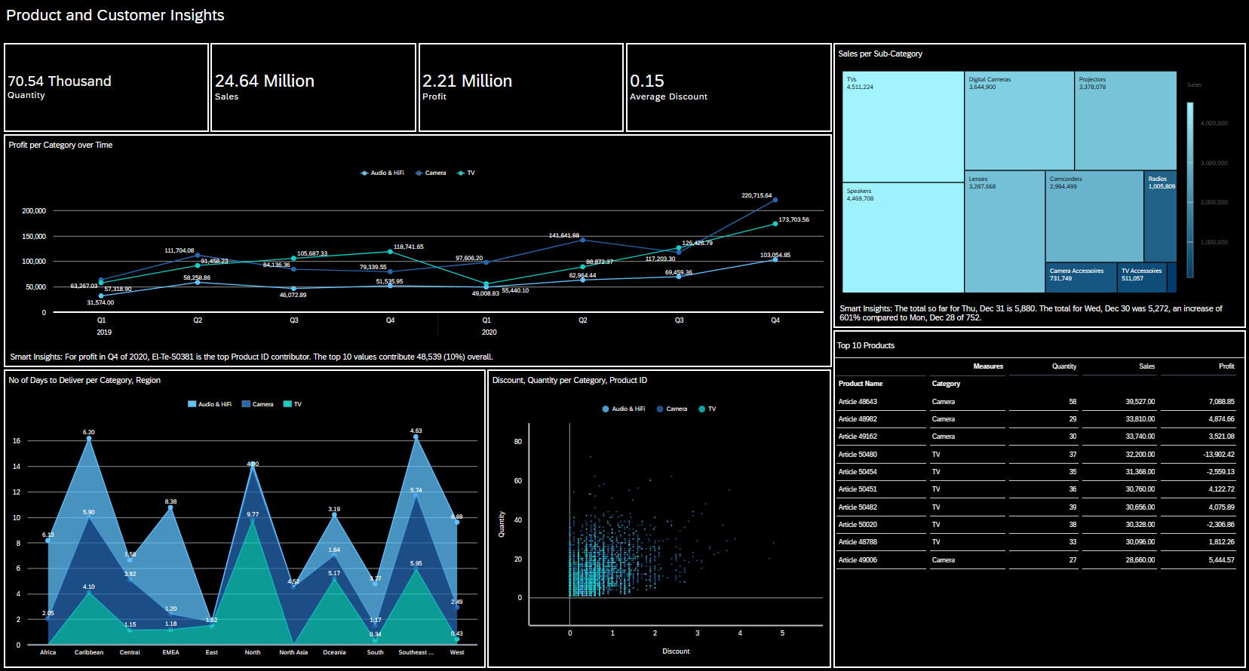
Product and Customer Insights

The dashboard provides an overview of product performance, profitability, customer purchase behaviour, and delivery patterns across categories. It is especially useful in comparing insights to uncover trends in sales strategy, product logistics and customer engagement.

The KPIs at the top shows the total quantity sold of 70.54K, total sales earned of 24.64M, profit of 2.21M and the average discount of 0.15.

The Profit per Category over Time line chart shows that the Camera and TV categories dominate the profits, especially in Q4 2020, where Camera saw a sharp increase to 220K in profit. This can be compared with the Top 10 Products table where 4 out of the 10 high-performing products are cameras and they all have strong profit values. However, when comparing this with the Sales per Sub-Category treemap, TVs and Speakers contribute the highest sales, while Cameras are slightly behind in volume. This indicates that Cameras have higher profitability per unit, while TVs probably focus more on sales volume.

When comparing the No of Days to Deliver per Category and Region with the Profit per Category over Time, we can see that TVs, despite longer delivery times in regions like North and Southeast Asia, still yield strong profits. This shows that customers will willingly tolerate longer delivery for their high value TVs. On the other hand, Audio and HiFi sees shorter delivery times across most regions but show lower profit, indicating that deliver speed does not guarantee profit and that the product type and demand also matters.

Lastly, the discount vs quantity scatter plot reveals that most high-volume transactions occur within the 0 to 1.5 discount range, suggesting that discounts are not the main sales driver for most products. When comparing with the Top 10 Products table it can be seen that some TV articles show losses while others are profitable, suggesting that discounting and profit outcomes can vary significantly even if the products are within the same category.

Overall, there are several key product insights. The Cameras offer the best profit margins with consistent delivery and moderate discounts; hence they could be prioritized for margin-focused strategies. Additionally, the TVs has massive sales volume but varying profitability and high delivery days, showing a potential flaw where people are buying the TVs due to the discounts on them. Audio and HiFi products has low profits despite having good delivery times, hence suggesting the need for product reposition or bundling strategies.

Cost and Profitability
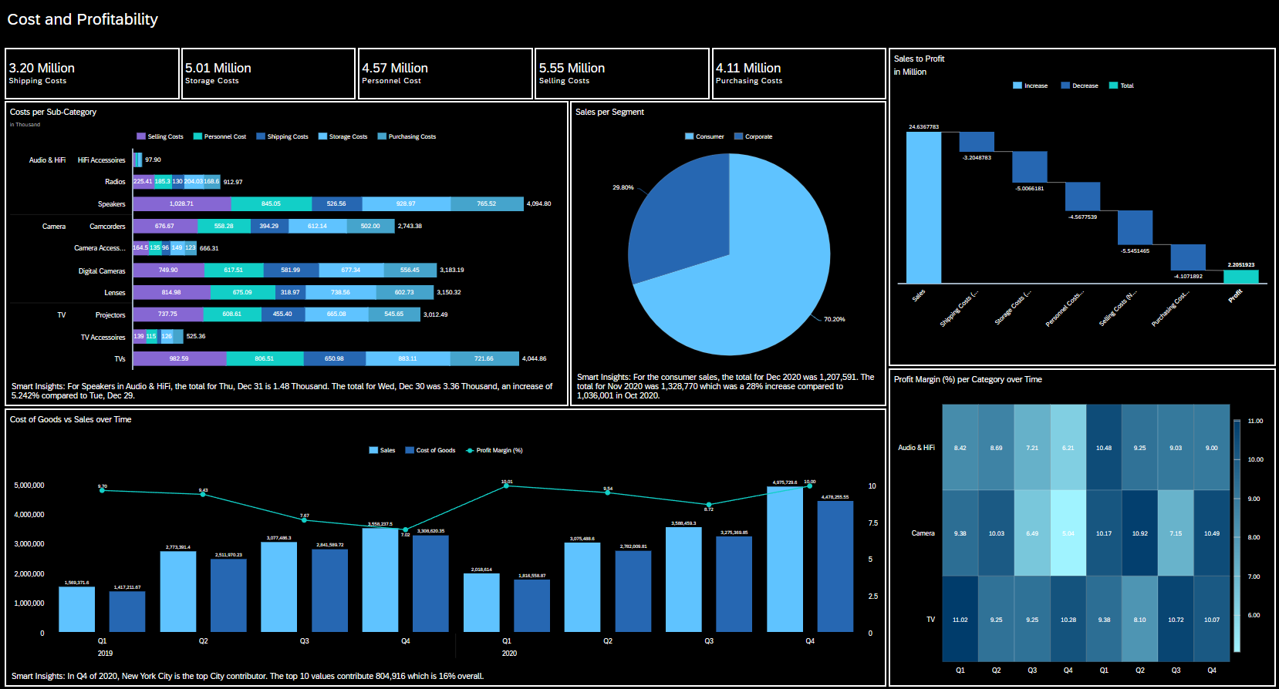

This dashboard shows the cost structure, profit generation, and segment breakdown for each costs. It allows them to analyse how the sales, cost categories and performance over time affects each other.

The KPI at the top shows the breakdown of the different costs, allowing one to instantly see which have the highest costs and lowest. They can determine ways to decrease these costs.

The Costs per Sub-Category bar chart reveals that Speakers and TVs have the highest total costs across all categories, with high Selling, Purchasing and Storage costs. This is validated in the Sales to Profit waterfall chart where Selling Costs alone contributed a decrease of 5.55 million, the highest among all the cost categories. Additionally, when comparing with the Profit Margin per Category over Time heatmap, it can be seen that TV consistently maintains high margins, even in quarters with high operational costs. This means that there are effective pricing strategies that preserve profitability despite higher cost inputs.

The Cost of Goods vs Sales over Time chart shows a rising trend in both Sales and Cost of Goods from Q1 2019 to Q4 2020. On the other hand, the Profit Margin peaked at Q1 2020 before decreasing even though sales was climbing. This suggests that profitability is not only driven by sales but also by how the costs are managed, which is supported by the rising Cost of Goods. When comparing with the Heatmap, TV maintained stable margins, while Camera experienced a drop in Q3-Q4 2019. This suggests that Camera contributed more to the overall drop in profit margin as compared to TV. Hence, TV is more cost-efficient and reliable while Camera is more sensitive to operational cost changes.

The Sales per Segment pie chart shows that 70.2% of the revenue comes from the Consumer segment. By comparing this with the Sales to Profit chart, it can be inferred that most costs like shipping is likely driven by business to consumer logistics, but profitability is still maintained. Hence, the consumer segment remains their main target audience despite higher servicing costs.

Overall, there are several key costs insights. By determining that TV is the most cost-resilient category, they can prioritize product development and promotion for this category. Additionally, the frequent fluctuating margins for Camera suggests a need for better cost control. It can also be seen that the sales growth is outpacing the margin growth, they should shift their focus to cost optimization to protect future profit margins. Finally, since the consumer segment is driving revenue, logistics, marketing and pricing strategies should be optimized for this target group.

Smart Discovery
The Smart Discovery Feature gives further insights on the dataset that I could have possibly missed out on. The smart data discovery feature helps save time by running machine learning algorithms in the background to find correlations between the dataset and target metric. By clicking the measures used, one can view the anomalies in the data, run what-if cases and find patterns in the data to predict the future.

In this case, I decided to use Smart Discovery to see profit demographics related to customer behaviours. This includes market, segment, region, category and ship mode.

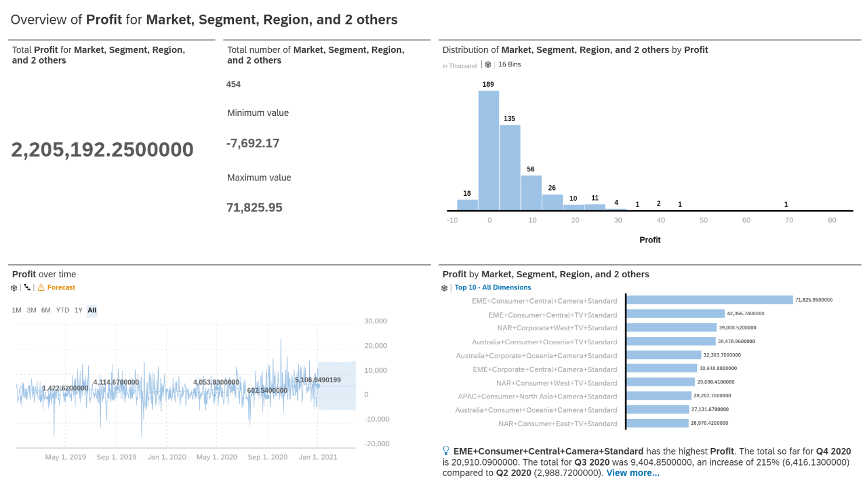
Overview

From this, Smart Discovery provides an overview of how the different measures corelate to affect the profit. It uses distribution charts, time series and bar to compare the individual features of the dimensions put in. For example, in the bar chart, each bar includes a Market, a Segment, a Region, a Category and a Ship Mode to calculate the profit. Additionally, the time series chart shows the profit change over time and the forecast.

Key Influencers
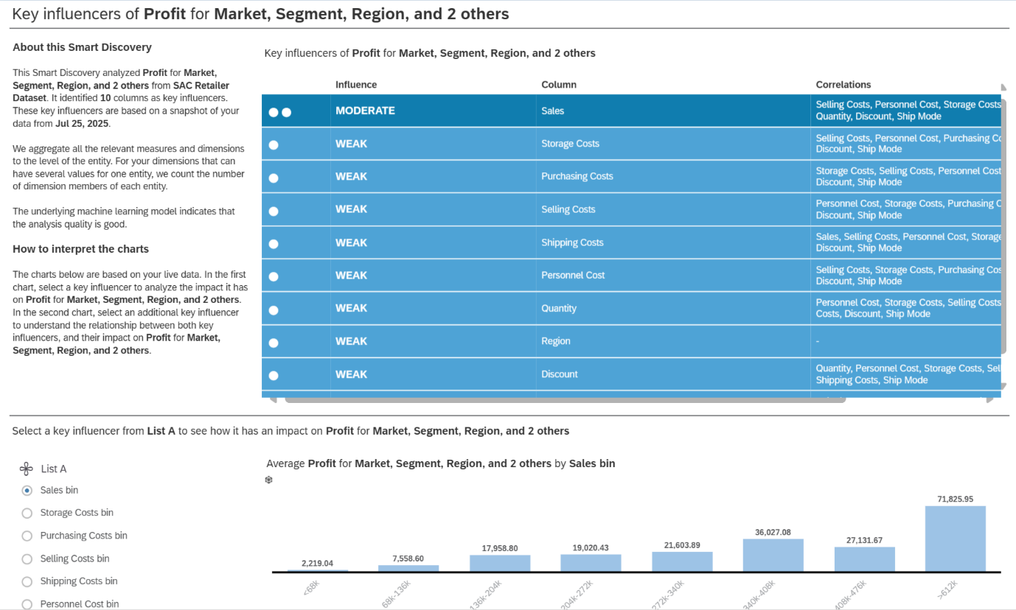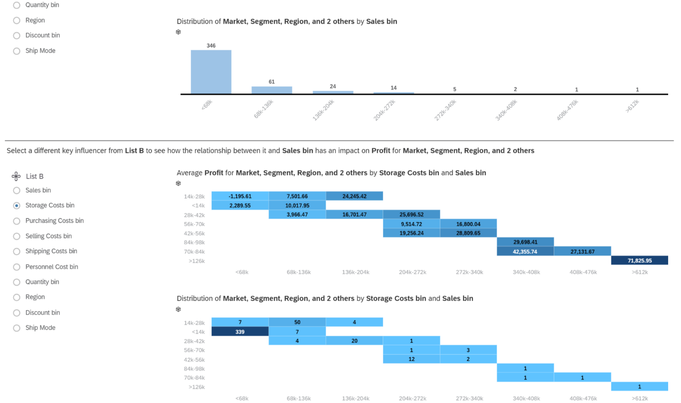
The above Smart Discovery shows the key influencers that affect the Profit and what that measure is correlated with. One can select an influencer from List A to see its impact on the Profit and List B to see how its relationship with Sales has an impact on the Profit.

Simulation
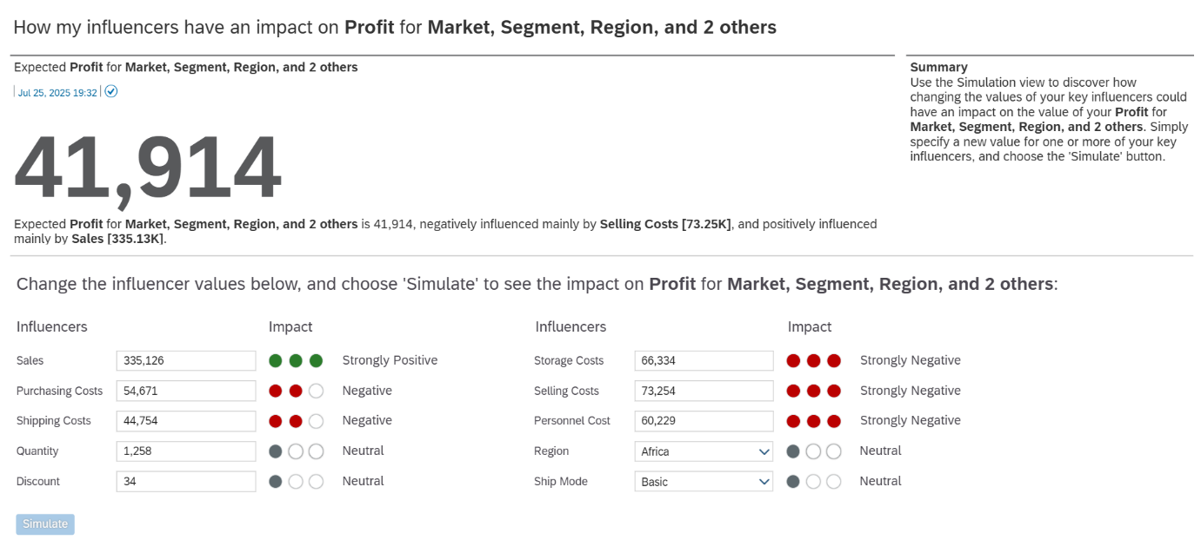
This smart discovery shows how the different key influencers affect the profit. It includes Sales that has a strongly positive impact since profit is derived from Sales. Additionally, the costs all have a negative impact as they are what take away from the Sales. Previously, it was determined that the costs are not currently being managed properly. Hence the expected profit could actually be a larger value than 41,914.

Reflection
Regarding SAC
Over the past few weeks of using SAC, my knowledge on it went from 0% to now probably 80%. Since we have previously used Power BI and Tableau before, I was quite exited to try out SAC and see how it compares. After doing the exercises, I was quite confident that I knew everything and was ready to tackle the assignment. However, I encountered several setbacks.

Firstly, the interface that was in the examples was an older version and hence different from the actual website. This resulted in me struggling to find certain buttons when doing my graphs. Additionally, I realised that the exercise was very limited to only a few graphs and sample. Hence, I had to explore the website a lot more myself to figure out how to get the graph to look like how I wanted it to. This resulted in me spending a lot more time than I had expected.

Secondly, I also had troubles creating the calculated fields as the exercise did not teach me the different style of calculated fields SAC has to offer. When I first tried to create calculated fields, I realised it was not just writing formula like excel. There were also other types such as unit conversion, aggregation, dimension to measure and more. I used these to my advantage and created calculated fields like Profit Margin, Number of Delivery Days and more.

Eventually, after exploring the website more, I was able to complete the assignment and create my ideal graphs and dashboard. What stood out to me and what I thought was especially useful was the Smart Insights and Smart Discovery features. They helped me to automate some of the data analysis, allowing me to focus more on interpreting the trends and thinking of possible decisions for the company. This is something that I did not find as seamless in Power BI or Tableau as they only allowed me to create graphs.

When comparing to Power BI or Tableau, I find SAC interface more confusing to navigate. Tableau was more straightforward where we just had to drag in the fields. The labelling function, colour and filtering was also all in the same bar. Whereas, for SAC I had to go find it individually and click on specific components of the graph to edit their colours. However, after further thought, it is probably more confusing to navigate due to its additional features. SAC has many additional features that makes it stand out in corporate environments.

Regarding talk by SAP
Through the talk by SAP, I learnt that they did not just do data visualisation. They also have things like back end development, international trade, financial accounting and more, which I found really interesting. I realised how broad SAP actually is and realised how important enterprise systems like SAP is in modern business operations. Furthermore, Abeam, taught me more about the importance of stakeholder’s communication in project management. Being able to create insights is important. However, it is also very important to maintain good communication with stakeholders, this includes meetings, presentations, emails and more. It is important to align one’s insights with the business needs and to know when to change the insights.

Regarding the Module
From this module, I have learned more about business processes. From the first assignment where we had to do the full procurement process, to this assignment where we have had to create graphs for businesses. I have learnt how closely data science is related to businesses and how crucial it is to understand data at a business level to support decision making. This module has given me the practical exposure to experience business processes first hand.

What I have learnt in this module would be important for internships. It allows us to look at not just tech giants for internships but also other industries that require data scientists on their team for business insights. If I were to redo the practical, I would probably focus more on making the dashboards more user friendly. Currently, the dashboards may be a bit elaborate to people who do not understand graphs.

Overall, this module reinforced enterprise systems and how important it is to be business smart and have organizational intelligence. The other modules teach me more of building and training modules which is more backend. Whereas, IES teaches me more integrative skills, connecting data analysis, visualisation and business strategies.

